The Six-Step Community Change Model Toolkit

About this Toolkit

What is Community Change?
Community change happens when people work together to identify shared challenges, build on local strengths, and improve the places where they live, learn, work, and play.
While personal choices matter, they are shaped by the conditions and opportunities available. Community change focuses on creating environments that make positive choices possible and accessible for everyone. It can take many forms, from improving food access to strengthening transportation, housing, or community spaces.
In this toolkit, we focus on changes that support access to healthy food and safe, welcoming opportunities for physical activity.

MSU Extension’s Six-Step Community Change Model
MSU Extension’s Six-Step Community Change Model is a practical approach that helps people work together toward positive community change. The six steps guide users to identify shared challenges, bring a team together, build upon local strengths and reliable resources, take action, and sustain community change.
Designed for parents, educators, childcare providers, residents, volunteers, local leaders, and others, the model emphasizes small, realistic changes that fit local capacity. By building upon existing strengths, these tools help save time, reduce the need for retraining, meet funding or quality requirements, and keep positive practices in place. Even modest steps can lead to lasting benefits for staff, families, and the broader community.
This model was adapted from over 30-years of programming experience, developed resources, and vetted tools that once supported the MSU Extension SNAP-Ed program that ended in October 2025. It is grounded in several widely used, evidence-informed frameworks that support public health planning, systems change, and evaluation, helping ensure changes are thoughtful, effective, and sustainable. It is meant to continue providing guidance to communities as a stand-alone, self-guided tool.
While the Six-Step Community Change Model (see Figure 1) can be applied to many types of community improvements, from downtown revitalization to arts, culture, and transportation projects, this toolkit applies the model to nutrition, physical activity, and community health changes. It includes real world examples and easy to use resources to make everyday places healthier.
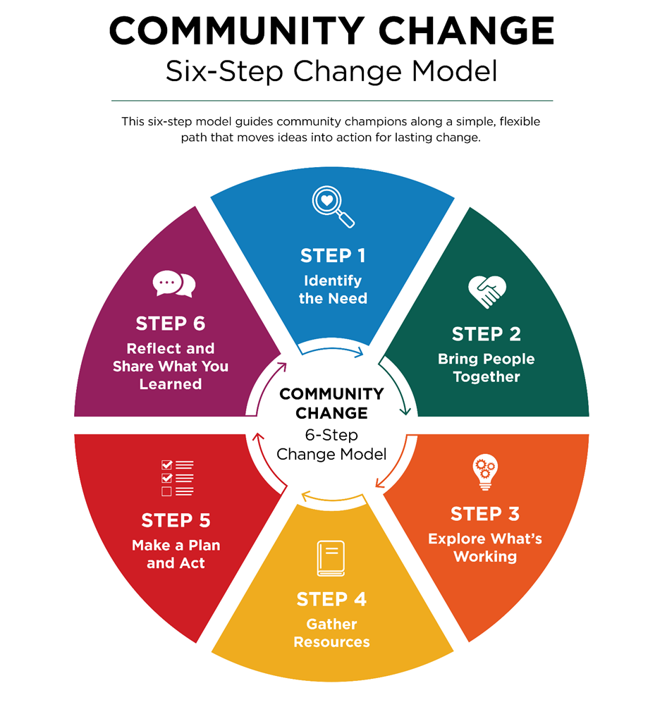
Figure 1: MSU Extension’s Community Change Six-Step Model.

The Role of Community Champions
Community champions are trusted local individuals who help move ideas into action across the Six-Step Community Change Model. They play four key roles (see Figure 2):
- Mobilizing people to take initial steps
- Connecting partners and resources
- Shaping practical, community-driven solutions
- Sustaining momentum over time
By encouraging small, doable actions and building strong relationships, champions help groups stay focused, adapt as needed, and carry changes forward in ways that reflect lived experience and local priorities.
Anyone can be a community champion. They don’t need special training, a job title, or formal authority. Lived experience, care for one’s community, and a willingness to take action are the qualifications that matter most.
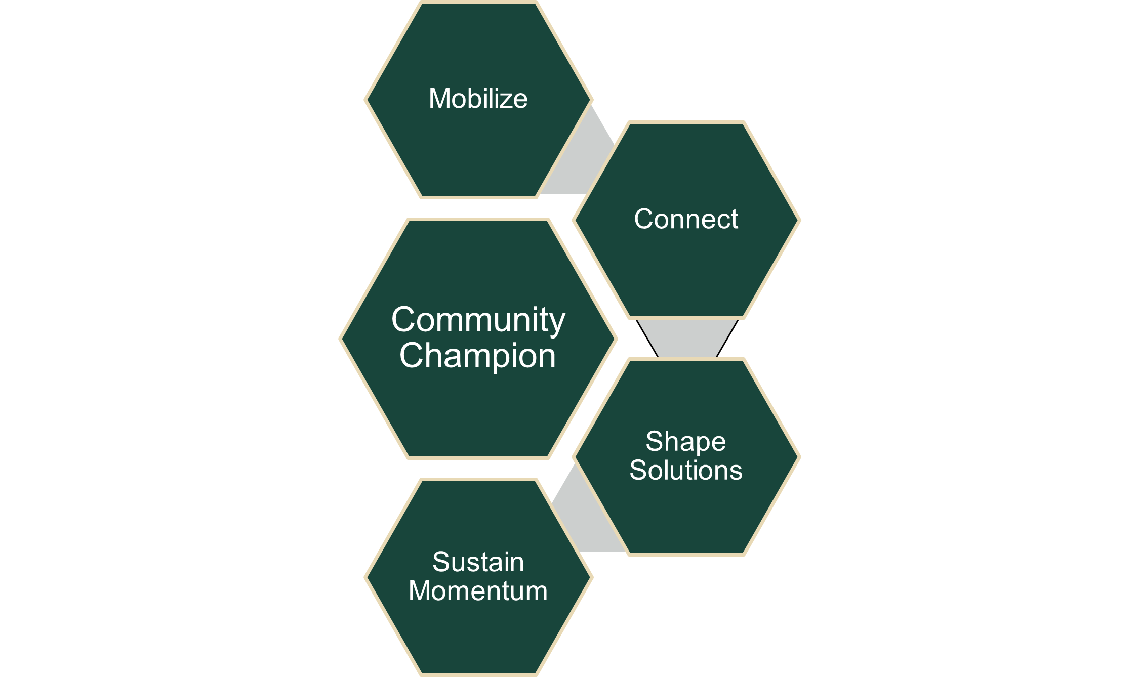
Figure 2: The Four Community Champion Roles.

How to Use this toolkit
This Six-Step Community Change Model Toolkit was created to be used in conjunction with MSU Extension’s Community Change Hub, a self-guided, virtual toolkit designed to help support healthier community environments.
The Community Change Hub uses a five-site framework (collectively called "the Hub") to organize content and guide the user experience. Users can move between sites based on their needs, using the Hub as a flexible, self-paced system rather than a linear course.
The five Hub sites are:
- Community Change Hub: Introduces the Community Change Model and the roles of the community champion and explains key concepts.
- Champion Early Health: Provides strategies that support healthy beginnings for families and communities, from pregnancy to early childhood.
- Champion School Wellness: Shares ways to develop student wellness through good nutrition, food access, and active learning.
- Champion Food Access: Describes how to support change work that helps connect people to food.
- Champion Active Communities: Shows ways to promote active living from childhood through adulthood.
Each "Champion" site includes examples of healthier environments brought about by the Six-Step Community Change Model. In Community Voice Guides, users will see the six steps applied to specific focus areas like food pantries and community gardens, supportive breastfeeding spaces, school and childcare environments, and physical activity settings. These Guides, plus resource listings and stories of change, will inspire community champions toward their own community work.
This Six-Step Community Change Model Toolkit is a downloadable, printable resource available on the Community Change Hub. With a guide and worksheet for each step, it supports community champions and their teams in taking thoughtful, guided action toward community change. The Hub offers real-world examples to spark ideas, but the toolkit is designed to help teams adapt those ideas or create their own based on their unique community strengths, needs, and goals.
Access the Community Change Hub and the four Champion sites at extension.msu.edu/changehub.

Guides and Worksheets for the Six Community Change Steps

Step 1: Identify the Need

Guide: Identify the Need
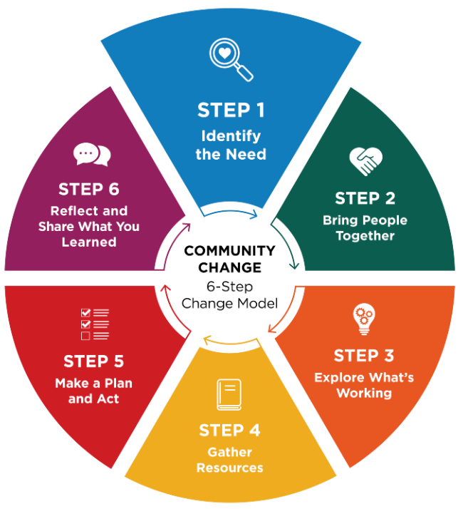
Community champions help bring priorities to light through conversation and observation.
Identifying a need means naming something that makes it harder for people to eat well, access healthy food, or be physically active. You can uncover needs by observing your community, having conversations, and listening to what people care about.
A strong community need should:
- Support healthy eating, food access, and/or physical activity
- Affect many people, not just one individual
- Reflect what community members and staff are experiencing and saying
- Name the place or setting where improvement can happen

Support healthy eating, food access, or physical activity
Think about how the need connects to healthier food or opportunities to be active. For example, limited produce options at a local store or a lack of safe places to walk may signal an opportunity for improvement.
Ask:
- What challenge or opportunity do you see that relates to eating well or being active?
- If you could dream big and anything was possible, what would you change or improve?

Affect many people
A strong need should impact more than one person. Look for patterns or issues that several parents, students, staff members, or neighbors experience. If the need affects a group, it is more likely to create meaningful, lasting change.
Ask:
- What group of people is being impacted?
- Who will benefit from a change being made?

Reflect community voices
Talk with staff, partners, community members, and program participants to understand what people are experiencing. Listening helps you learn why the need matters and what the benefits could be.
Open‑ended questions help people share more about their goals and challenges. They also build trust and help you understand the issue in their own words.
Examples of open‑ended questions:
- If things were working really well, what would that look like?
- What are your goals related to nourishing food and physical activity?
- What’s getting in the way of reaching these goals?
- What’s already going well that we can build on?
- What opportunities do you see for change?

Name the place or setting
Be clear about the space where change can happen. This could be a school, neighborhood park, food pantry, community garden, childcare center, workplace, or another local setting.
The clearer you are about what will change and where it will happen, the easier it is to understand the need and support the effort.
Ask:
- Where does this need show up?
- What specific improvement could make a difference?

Worksheet: Identify the Need
Use this worksheet to identify a priority need that reflects lived experience, affects many people, connects to healthy eating/food access or physical activity, and clearly names the setting where change can happen. Community Champions can help surface insights and mobilize early conversations.

1. Choose your focus setting

Where is this need showing up? (choose one)
- A classroom or group of people
- A school building or district or community program site
- An early childhood setting (center, home-based, classroom)
- A community organization (nonprofit, coalition, agency)
- A healthcare setting (clinic, WIC, hospital program)
- A food resource setting (pantry, market, distribution site)
- A workplace or staff team
- A lactation or breastfeeding support setting (lactation room/space, staff/parent supports)
- Other: _____________________________________________________________

2. What challenges or opportunities are you noticing?
Be specific and connect to healthy eating, food access, or physical activity. Examples: “Kids sit for long periods,” “Families don’t know where to start,” “Healthy foods are hard to access,” “Staff need support for breastfeeding/lactation.”
What we’re noticing: _____________________________________________________

3. How do you know this is a need and affects many people?
Choose all that apply:
- Staff observations
- Participant/client feedback
- Community feedback
- Data (surveys, participation, incident logs, program data, etc.)
- Policy/compliance requirements
- Other: _____________________________________________________________

4. Why does this matter to our community?
If this issue improved, what would be different?
For participants/community: ______________________________________________
For staff/operations: ____________________________________________________

5. What community voices or perspectives informed this need?
Choose all that apply:
- Community members directly affected
- Staff or volunteers
- Families or caregivers
- Neighborhood or community groups
- Partners or collaborating organizations
- Community leaders
- Data that reflects community experience (Community Health Needs Assessment, local data, etc.)
- Other: _____________________________________________________________

6. What are the benefits we hope to see?
Choose all that apply:
- Increased physical activity (more movement and less sitting)
- Improved access to nourishing food (food access or food/nutrition security)
- Healthier food and beverage choices
- Improved health and wellness outcomes for participants and families
- Reduced barriers to healthy choices in the organization or setting
- Stronger routines, systems, and supports that make healthy choices easier
- Other: _______________________________________________________________

7. Community champion contribution (who + how)
Which champions helped identify this need and how did they contribute? (Mobilize, Connect):
_______________________________________________________________________

Step 2: Bring People Together

Guide: Bring People Together
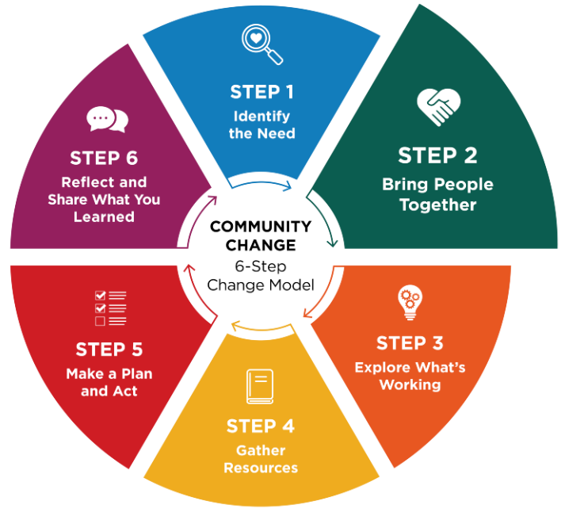
Community champions often act as connectors who help engage overlooked voices, bridge sectors, and energize others to turn ideas into action.
Real change happens when people come together, talk openly, and listen to those who are closest to the issue. When you create space for honest conversation, about what is working and what could be better, people feel invited to take part. When people feel heard and their ideas matter, they are likely to take ownership. That sense of ownership is what helps change last.

Think about who should be involved
Start by identifying who needs to be part of the conversation from the beginning.
Consider people who:
- Care about the issue
- Directly impacted by the issue
- Make decisions or influence how things are done
- Understand how the setting works day to day
- Have valuable insights but may be overlooked
- Are trusted, motivated, and able to help move ideas forward
For example, local law enforcement officers may understand safety issues that affect food pantry outreach. Youth often offer perspectives adults may miss. Some of these individuals may become community champions.
Having people from different sectors—such as schools, nonprofits, health care, businesses, or local government—can help the group share resources and ideas. Using a shared approach, such as the Collective Impact Framework, can strengthen the group’s results.

Questions to help guide your outreach
Ask:
- Who cares about or is impacted by this issue and wants to see improvement?
- Who can help make decisions or influence next steps?
- Who has the time, skills, or resources to support this work?
- Who has strong relationships with the people affected?
- Who could help turn ideas into action?
- Who are the philanthropic partners that might support the work?

Identify someone to guide the process
It is helpful to have a dedicated point person who can guide the group and keep the work moving forward. This individual could be someone from your organization or a partner willing to assist. While partners can provide valuable support and guidance, the organization or group closest to the issue should take the lead in decision-making, driving action, and sustaining the changes over time.
Tip: Consider using a facilitator
It may be helpful to invite an outside facilitator for your first meeting. A trained facilitator can guide the conversation, help generate ideas, identify challenges, and make sure all voices are heard—especially when the group has diverse needs. MSU Extension does support community groups through visioning and action planning.

Worksheet: Bring People Together
Identify who should be part of the conversation from the beginning. Community Champions often act as connectors who engage overlooked voices and build trust across sectors.

Identify sectors of interest
Folks may come from different sectors across the community, or they may all come from a single organization. Public sectors to consider are:
- Agriculture
- Childcare
- Commercial marketing/local business
- Community design/planning
- Community members (including youth or elders)
- Education (school, after-school programs)
- Food industry (producers, distributors, and processors)
- Food retailers (grocery, corner store, farmers market)
- Government (local, county, tribal, state)
- Health care (clinics, hospitals, educators)
- Local Food Policy Councils or networks
- Media
- Neighborhood groups
- Public health
- Public safety
- Social/human services
- Transportation

Who should be involved?
Write down individuals or organizations who can join you, and how you might reach out to them.

Sector/Group | Specific Individuals or Organizations | Champion(s) to Engage | How We’ll Invite/Engage

Reflection
- Who are the people impacted by the issue and how will their voice be heard?
- Do you have the right people at the table? Are any key people or sectors missing from your list who can help make decisions and influence next steps?

Step 3: Explore What’s Working

Guide: Explore What’s Working
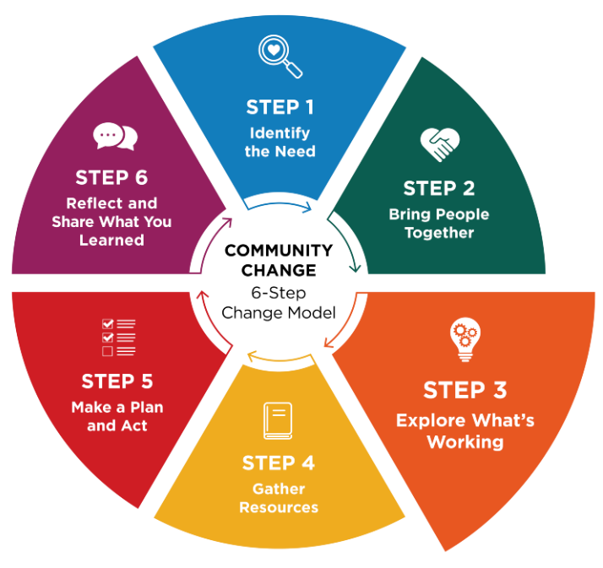
Community champions contribute insight into what has worked before, ground options with real needs, and help define what matters most to the community.
Before choosing your next steps, it helps to understand what things look like right now and what has worked well in the past in your community or other communities. This means paying attention to what is already helping, what has been successful, and what might be getting in the way. When you understand current conditions, you can make thoughtful decisions about where change would be most useful.

Look at everyday practices and spaces
With your partners, take time to observe the setting, talk through routines, and think about the places where people spend time. This helps you notice strengths, gaps, and opportunities for improvement.
You may find it helpful to keep a list of guiding questions on hand during your discussion.
Questions like these can get the conversation started:
- What’s working well—and what has worked well in the past—that we can build on?
- Are there current practices we could improve?
- Where do people feel stuck or frustrated?
- Are there patterns or gaps that seem important to address?
- Are there opportunities to make healthy choices easier?
- What changes have you already been thinking about?
- Is there anything in the data that supports the direction you’ve been considering?
- What would make the biggest difference for clients, students, or the community?

Consider readiness for change
It is also important to think about what nutrition and physical activity changes you are ready to act on. Readiness includes confidence, motivation, capacity, and feeling supported. When people feel ready, changes are more likely to stick.
By understanding both what’s happening at your site currently and how ready your team is, your team can choose the next steps that feel realistic, meaningful, and doable for the group.

Use tools or structured approaches when helpful
In some situations, tools can help organize the conversation. For example, Appreciative Inquiry is a process that focuses on what is going well and how to build on those strengths. In other cases, simply having a goal-oriented discussion or walking through the setting together can help people notice what could improve. Choose an approach that helps people feel comfortable sharing ideas and noticing possibilities.

Worksheet: Explore What’s Working
During conversations with the group, it may be useful to capture their perspective on:
- What’s working right now or has worked?
- What feels true about the current situation?
- What do you hope things could look like in the future?
- What might make it hard to get there?

Activity
Write each of the four headings (see below) on large sheets of paper and post them around the room. Give each person sticky notes and ask them to write one idea per note. Then have them place their notes under the heading that best fits their idea.
After all the notes are posted, read them out loud together. If something isn’t clear, ask the person who wrote it to explain. You can also group similar ideas to see patterns.
If helpful, a neutral facilitator can guide the conversation and make sure all voices are heard. MSU Extension is available to support community groups through visioning and action planning.

Step 4: Gather Resources

Guide: Gather Resources
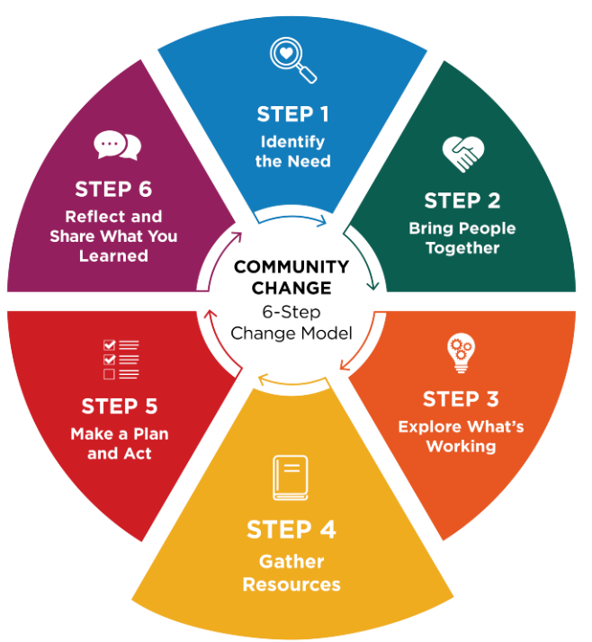
Community champions often know partners and are passionate about choosing practical strategies that fit the community.
Once you have explored what is working and what could be better, the next step is to decide what your group wants to do. Work together to choose realistic goal(s) and gather information that can help you reach it.

Look for reliable ideas and examples
Start by reviewing trustworthy resources, practical strategies, and real‑world examples. Talk with your group about tools or ideas that could move your goal forward. Ask if anyone knows another place — or a person — who has tried something similar.
You may also want to:
- Visit communities or sites that have used successful approaches
- Connect with community champions who have done similar change work
- Observe what makes their approach effective
Seeing what others have tried can spark ideas and help you understand what might work in your setting.

Use trusted sources
The MSU Extension Community Change Hub brings together trusted resources on school wellness, food access, active living, and early childhood health to help communities make informed decisions and act.
When reviewing additional online materials, look for resources that highlight research or evidence-based practices.
Reliable, evidence-based information often comes from:
- Universities
- Professional organizations
- Government (.gov) sites

Talk with your team about what fits best
Discuss what strategies feel like a good match for your group’s goals and readiness. Partners may know about resources that:
- Describe promising or evidence‑based strategies
- Provide funding or financial support
- Help plan or carry out the work
Choose options that feel realistic and doable for your group.

Questions to consider
As your group begins planning, the following questions can help clarify what’s required and where to focus your efforts.
Ask:
- What does the group want to change?
- What resources are needed for success?
- Will financial support be needed?

Worksheet: Gather Resources
Choose strategies that fit your setting and identify tools/partners to support action. Champions help determine fit, connect to resources, and communicate the plan.

1. What kind of change are you trying to make?
Choose one or more that apply. This helps identify strategies that last.
- Change the rules, expectations, or policies (guidelines/standard practices/written procedures)
- Change the routine (schedules, workflows, checklists, or meetings)
- Change the space or what’s available (supplies, signage, room setup)
- Not sure yet

2. Decide on ONE clear goal to focus on first
It helps to begin with the desired change and decide on a goal that feels doable, useful, and meaningful for the people involved.
Goal: ____________________________________________________________________________

3. Consider examples of what works for others
Review the suggested examples and strategies provided in these four MSU Extension Community Change Hub areas of practice:
- Champion Early Health
- Champion School Wellness
- Champion Food Access
- Champion Active Communities
Then, come up with some ideas that may work for your change initiative.
Idea 1: ___________________________________________________________________________
Why it fits: ________________________________________________________________________
Idea 2: ___________________________________________________________________________
Why it fits: ________________________________________________________________________

4. What barriers might get in the way?
Choose all that apply.
- Time
- Space
- Staffing
- Money
- Buy-in
- Knowledge/skills
- Other: ___________________________

5. Choose ONE example or strategy to guide your next step
Resource name: ___________________________________________________________________
What you plan to use from it: _________________________________________________________
_________________________________________________________________________________

Reflection
- Are there barriers to moving forward such as readiness, time, money, people you have at the table? If yes, should you identify a different goal?
- Do your resources support moving forward?

Step 5: Make a Plan and Act

Guide: Make a Plan and Act
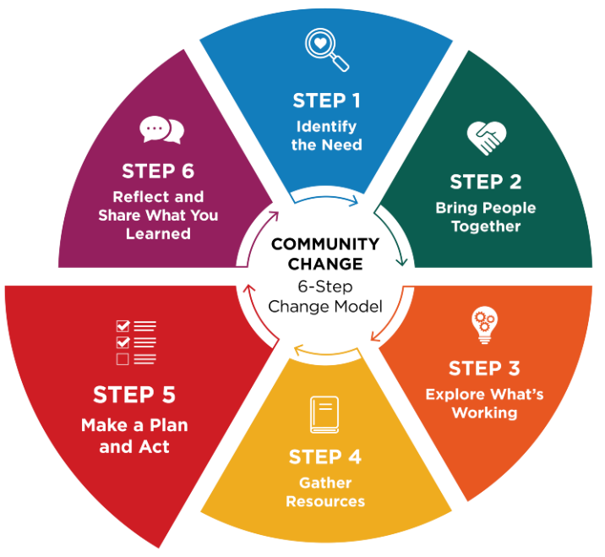
Community champions can help activate early wins and encourage participation.
Once you know what change you want to see and have decided on a goal (see Step 4), the next step is to create a plan to make it happen. An action plan turns ideas into concrete steps and is created by the people who care about the issue and can help move it forward.

Break a big goal into small, manageable steps
The purpose of an action plan is to make the work clear and realistic.
Each step should:
- Describe what needs to be done
- Name who is responsible
- Include a timeline
- List what is needed for success
- Identify who needs to stay informed
A strong action plan answers questions like:
- What small steps could help us reach our goal?
- What are we going to try?
- Who is responsible for each task?
- When will changes be made?
- What help or resources do we need?
- Who needs to know about the work as it moves forward?
- How will we know we succeeded or what do we need to track?
- What early “win” will get and keep the group engaged and excited for next steps?

Keep the plan flexible
An action plan is a living tool. As the work begins, the plan should be revisited and updated. Adjusting the plan helps the change team stay focused on what is working and respond early to challenges or new opportunities.
Using the action plan during regular team check-ins supports follow-through and keeps the group moving forward.
Tip: Use regular check-ins to build momentum
Check-ins help the team stay connected, motivated, and ready to adapt. During check-ins, you can:
- Celebrate early successes
- Identify challenges or new ideas
- Adjust the plan as needed
- Discuss next steps

Worksheet: Make a plan and act
This section helps you create an action plan by showing an example and providing an action planning template and steps to develop a clear communication plan. If a policy is something your team has identified as a possible tool for change, this section shows you how to build a simple, concise policy.

action planNing worksheet
Review the example below that shows one way to develop an action plan, then use the template to create your own action plan.
Tip: Identify an early win.
As you shape your action plan, think about a small, early success that engages your team and helps build momentum for continued progress.

Sample action plan
Example Goal: Increase 1-2 daily physical activities by establishing regular movement breaks into the day at ABC Elementary School.

What action needs to be taken? | Who will be responsible? | When will this be done? | What resources are needed for success?
Introduce the initiative, share activity ideas with teachers. | School wellness coordinator | Introduce the plan at the next staff meeting. | - The district wellness policy  - A list or menu of simple movement activities
Choose daily movement break times. | Teachers | A week before school-wide implementation | - Menu of movement activities
Implement movement breaks school wide. Coordinator visits classrooms to support implementation. | Teachers with support from coordinator | October 1 | - Posters or cards with movements
Track participation and gather feedback from teachers and students. | Coordinator | November 15 | - Digital participation tracker and simple student survey
Review progress and adjust activities as needed. | Coordinator with school leadership | December 1 | - Results of participation and student feedback

Action planning template:

Our Goal:

What action needs to be taken? | Who will take responsibility | When will this be done? | What resources are needed for success?

Communication planning
As action is taken, consistent communication with those that are involved and those that need to be aware is recommended. Consider who needs to know, how often will plan review be done, and how will progress be shared?
Who needs to know? | Frequency | How shared

Reflection
- Are there any important steps missing from the plan to make it work?
- Will the plan likely lead to the desired change?
- Connecting the dots, will the change meet your identified need?

Policy Development Worksheet
Are you considering a written policy or updating a current policy as part of your action plan?
A policy is a written statement that explains what a group plans to do, how they will do it, and who it will cover by guiding behavior and decisions through clearly written expectations and procedures. A good policy also makes sure that everyone is involved and on the same page and is a useful strategy for creating and maintaining desired change. Policies can range from simple statements to more detailed documents but ultimately serve as a supportive framework.
This worksheet provides a policy writing template and an example policy. Writing a policy can be a very simple to very complex process, depending on the desired outcome. Below are 10 things to consider when writing a policy.

1. Policy title
A policy name can alert the reader to what and who the policy will cover.
Name of your policy: _________________________________________________________________

2. Purpose
The policy should explain how healthy eating, regular physical activity, or access to nutritious foods will be supported in the community. Consider a goal that makes it easier for people to choose and have access to healthy foods or stay active in safe, welcoming spaces.
Purpose of your policy: ______________________________________________________________________________________________________________________________________________________________________________________________________________________________________________________

3. What this policy covers
Decide what your policy applies to. Examples may include food and beverages that are provided or sold; nutrition education and messaging; or physical activity opportunities and spaces. It should also identify who the policy will affect. Consider staff, participants, visitors, or community members.
Policy coverage: ______________________________________________________________________________________________________________________________________________________________________________________________________________________________________________________

4. Key terms
Consider including key terms that need to be defined in the policy. Examples may include definitions like these:
- Healthy foods: Foods that are rich in nutrients, such as fruits, vegetables, whole grains, lean proteins, and water.
- Physical activity: Any movement that helps the body stay strong and healthy, like walking, stretching, or playing sports.
- Supportive environment: A place that is clean, safe, and makes healthy choices easy and accessible.
Key terms to include in policy: ______________________________________________________________________________________________________________________________________________________________________________________________________________________________________________________

5. Commitments
As the policy is being written, identify what is being committed to. Examples may include:
- Offering and promoting healthy food and drink options
- Encouraging regular physical activity
- Making sure spaces are safe and welcoming for movement
- Providing clear, simple information about healthy choices
- Supporting people of all ages, abilities, and backgrounds
Commitments to include are: ______________________________________________________________________________________________________________________________________________________________________________________________________________________________________________________

6. Actions to take (to put the policy into practice)
As a result of the policy being written, what actions need to happen and when? Below are a few suggestions:
Nutrition Supports
We will:
- Provide healthy food and drink options at events, meetings, and programs
- Limit sugary drinks and less healthy snacks
- Make water available and accessible at all times
- Share easy-to-understand nutrition information
- Support breastfeeding and safe infant-feeding practices (if relevant)
- Establish a salad bar in our cafeteria
Physical Activity Supports
We will:
- Provide safe indoor or outdoor spaces for movement
- Encourage activity breaks during long meetings or programs
- Offer or promote walking groups, fitness classes, or active play
- Make sure activities are inclusive and accessible for all abilities
- Promote active transportation when possible (walking, biking)
- Make the school playground available for use during afterschool hours
Policy actions to take will be: ______________________________________________________________________________________________________________________________________________________________________________________________________________________________________________________

7. Roles and responsibilities
As the policy is being developed, it is important to determine who will be responsible for what actions. Here are a few examples to consider:
- Leadership: Makes sure the policy is followed and provides resources
- Staff: Models healthy behaviors, supports activities, and reports concerns
- Participants/Community Members: Use spaces responsibly and share feedback
Who are the people and what are the responsibilities to make the policy successful? ______________________________________________________________________________________________________________________________________________________________________________________________________________________________________________________

8. Reporting concerns
Once a policy is written, determine what options are available for people to report their concerns.
Outline who can report a concern about the food, beverage, or physical activity spaces. For example, include how reports can be made and how they will be resolved:
- Speaking with a staff member
- Calling the main office
- Using the online or written reporting form
We will review concerns promptly and take action. How will concerns be handled: ______________________________________________________________________________________________________________________________________________________________________________________________________________________________________________________

9. Monitoring and success tracking
Once the policy is written, it will be important that it is reviewed regularly and updated if warranted. Include how this will be done. An example is:
We will regularly:
- Review the types of foods and drinks offered
- Check the condition and safety of activity spaces
- Ask for feedback from staff and participants
- Update this policy as needed
The policy will be reviewed and evaluated in the following way: ______________________________________________________________________________________________________________________________________________________________________________________________________________________________________________________

10. Communication
Informing staff, volunteers, and community members is important to show the investment being made, through the policy, in the health of the community. A simple statement will let the community know what to expect. Consider a statement like “We will share this policy with staff, participants, and community members. Updates will be posted in common areas and on our website.”
Policy communication plan: ______________________________________________________________________________________________________________________________________________________________________________________________________________________________________________________

Policy Example
Below is an example policy. Look for the various components mentioned above.
Scenario: A workplace writes a policy that supports adequate time and location for employees to breastfeed and/or pump at work.

ELG Factory Lactation Accommodation Policy
The ELG Factory is a breastfeeding-supportive employer. In accordance with the Federal PUMP for Nursing Mothers Act and the Michigan Breastfeeding Antidiscrimination Act, this company provides reasonable breaktime and appropriate accommodation for employees who need to express breastmilk during the workday. Employees may access these accommodations for as long as they choose to breastfeed or express milk.
All employees at the ELG Factory will:
- Be provided with a place to breastfeed or express their milk in a private space that is not a bathroom. It will be clean, functional for pumping, and shielded from view.
- Have an available refrigerator space to safely store their expressed breastmilk.
- Be provided with flexible breaks to accommodate breastfeeding or milk expression.
This policy will be applied to all employees who need this accommodation and will be implemented and enforced by shift supervisors and human resources staff. Supervisors are responsible for ensuring all their breastfeeding employees have access to these accommodations.
This policy will be reviewed annually by the ELG Health and Wellness Committee at the beginning of every year to ensure ongoing compliance with federal, state, and local laws. This policy is published in the employee manual and will be communicated to all employees in the annual employee update email. This policy information will also be provided to new employees during their onboarding. This policy will be communicated to all shift supervisors during the first staff meeting every year to maintain a supportive work environment for breastfeeding employees.
This policy was last reviewed and updated in March 2026.

Reflection
- What outcomes will the change in policy make happen?
- Will the change in policy likely lead to the desired change?
- Connecting the dots, will the policy change or update meet your identified need?

Step 6: Reflect and Share What You Learned

Guide: Reflect and Share
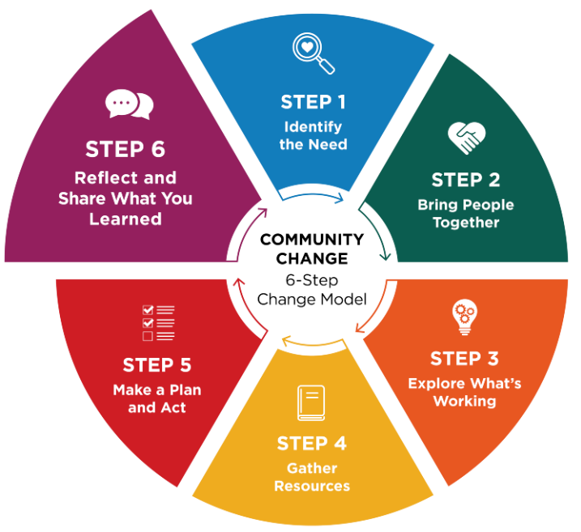
Community Champions often help share the story and celebrate progress.
This step is about looking back and telling the story of what changed. With your team, take time to think about what actions were put into place, what difference those changes made, and what you learned along the way. Taking time to reflect helps everyone see the impact of the work and appreciate the effort it has taken to make the change happen. Reflection can also help you understand what to keep doing, what to adjust, and what new opportunities might exist.

Questions to guide reflection
Ask:
- What changed because of this work?
- How did these changes affect people day to day?
- What worked well, and what was harder than expected?
- What would we do the same — or differently — next time?
- What opportunities does this change open for the future?
These questions help your team understand both the results and the process.

Why reflection matters
Reflection is often skipped, but it is an important part of lasting change. Taking time within two to four weeks of change completion to acknowledge everyone’s contribution(s) helps people feel valued and keeps them engaged. It also strengthens trust and ownership, which makes it more likely that successful changes will continue. Reflection can also help your group see new needs, modifications, ideas, or new opportunities to explore next.

Share your story
Highlighting accomplishments with the wider community can build interest and support for future efforts. Sharing your story helps others see what is possible — and may inspire them to get involved.

Worksheet: Reflect and Share
Track and reflect on what changed and how to keep success alive. Community Champions help tell the story and celebrate progress.

Success tracking
Goal: ____________________________________________________________________________
What has changed in the community because of our work? What did you try, and how did it go? ______________________________________________________________________________________________________________________________________________________________________________________________________________________________________________________
What felt easy?
______________________________________________________________________________________________________________________________________________________________________________________________________________________________________________________
What felt challenging?
______________________________________________________________________________________________________________________________________________________________________________________________________________________________________________________

What is ONE sign it worked?
Choose all that apply:
- Participation increases
- Daily routines feel smoother / fewer problems come up
- Staff report it feels easier or more supported
- Participants/families report benefits
- More consistent implementation across staff/site
- Other: _______________________________________________________________________

Success Tracking
This section emphasizes reflection and learning as part of evaluation. By documenting participation, outcomes, and lessons learned, you can assess progress, strengthen future efforts, and communicate results clearly.
Tracking Question | Gathering Information | Summarizing | Reflection
What success have you had? | Participation records, surveys, observations | How many people attended? What changed? | What worked and why? What still needs attention and improvement?

What will you do next?
Choose all that apply:
- Keep it going
- Adjust and continue
- Expand to other settings/groups
- Pause/stop and try something different
- Next step(s): ____________________________________________________________________

What will make it easier to continue and keep this success alive?
Choose 1-2:
- Build it into an existing routine or schedule
- Assign clear ownership (person/team)
- Create a simple checklist or system
- Communicate reminders
- Add signage or visual cues
- Improve access to needed supplies/space
- Other: ________________________________________________________________________
- How we will monitor: _____________________________________________________________

Who could benefit from hearing this?
- Staff/team
- Leadership
- Families
- Participants
- Community partners
- Other: _________________________________________________________________________

How will you share?
Choose all that apply:
- Quick email
- Brief staff update
- Conversation
- Posting/signage
- Newsletter/social media
- Other: _________________________________________________________________________

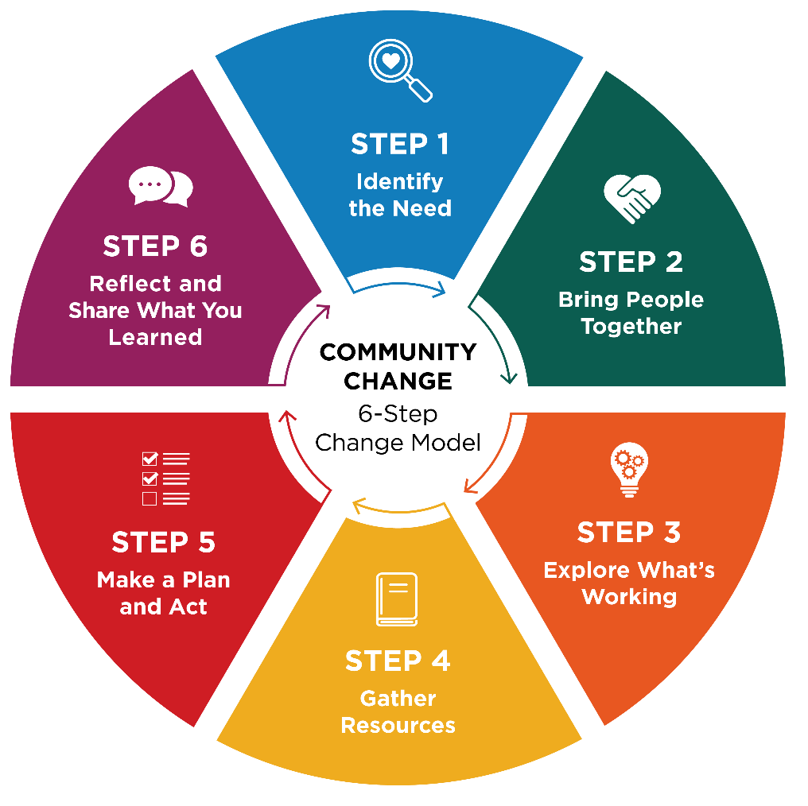
Congratulations -
You've completed the six steps!

Change doesn’t stop here. Build on your success and use what you learned to identify the next step your community is ready for.

References
CDC Program Evaluation Framework
CDC Program Evaluation Framework, Kidder, D. P., Fierro, L. A., Luna, E., Salvaggio, H., McWhorter, A., Bowen, S., Murphy-Hoefer, R., Thigpen, S., Alexander, D., Armstead, T. L., August, E., Bruce, D., Clarke, S. N., Davis, C., Downes, A., Gill, S., House, L. D., Kerzner, M., Kun, K., … CDC Evaluation Framework Work Group. (2024). CDC program evaluation framework, 2024. Morbidity and Mortality Weekly Report: Recommendations and Reports, 73(6), 1–37. https://www.cdc.gov/mmwr/volumes/73/rr/rr7306a1.htm

Collective Impact
Kania, J., & Kramer, M. (2011). Collective Impact. Stanford Social Innovation Review, 9(1), 36–41.

Mobilizing Action for Planning and Partnership (MAPP)
MAPP – Mobilizing for Action through Planning and Partnerships National Association of County and City Health Officials. (2008). Mobilizing for action through planning and partnerships: A community approach to health improvement [Fact sheet]. NACCHO. https://www.naccho.org/uploads/downloadable-resources/Programs/Public-Health-Infrastructure/MAPP-factsheet-system-partners.pdf

Plan – Do – Study – Act (PDSA)
Institute for Healthcare Improvement. (n.d.). Science of improvement: Testing changes. https://www.ihi.org/resources/Pages/HowtoImprove/ScienceofImprovementTestingChanges.aspx

PRECEDE - PROCEED
Green, L. W., & Kreuter, M. W. (2005). Health program planning: An educational and ecological approach (4th ed.). McGraw-Hill.

USDA Food and Nutrition Service SNAP-Ed Guidance
U.S. Department of Agriculture, Food and Nutrition Service. (2024). Supplemental Nutrition Assistance Program Education (SNAP-Ed) plan guidance: FY 2025. U.S. Department of Agriculture. https://www.fns.usda.gov/snap-ed

